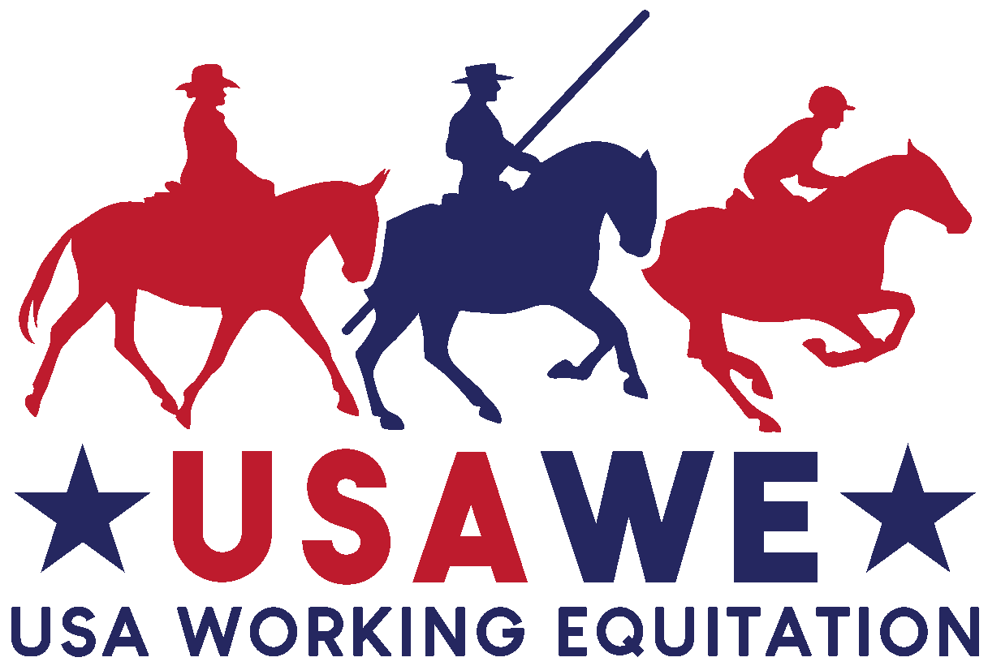

Your logo

Show Name

Show date(s):

Entries Open: ________ Entries Close: ________

Held at:

Show location

This show is licensed by
USA Working Equitation (USAWE)

Show Staff

Show Manager  Name  Contact info  Show Secretary  Name  Address  email  phone  Facility/Barn Manager  Name  Contact info | Judge(s)  Name  City, State  Technical Delegate  Name  Paddock Steward  Name  Veterinarian  Name  Contact info | Farrier  Name  Contact info  Safety Coordinator  Name  Contact info  Medical personnel  Name  Contact info  Announcer  Name

Competition Requirements

This show will be conducted and judged in accordance with the United States Rules for Working Equitation, Revision 4, dated 1 December 2020. The rules can be found at the following site: https://usawe.org/rules. It is the competitor’s responsibility to read and understand the rules prior to the competition.

All competitors holding a membership with USAWE may compete. Non-members are allowed to compete in licensed shows for a $20 non-member fee. Non-members can use a one-time voucher in place of the non-member fee. Competitors interested in competing at Championship shows must be USAWE members and earned qualified rides as a member.

Apply for the voucher online at: https://forms.gle/U68aZ2yTqNNBSvRA7

Competitors interested in being eligible for lifetime medal awards and year-end awards must be USAWE members.

Membership application: https://usawe.org/membership/:

All competing horses must be recorded with USAWE in advance of the show. A one-time fee of $20 per horse includes lifetime performance tracking.

Horse recording form: https://usawe.org/membership/:

A single horse and rider team is allowed to show in only one level. A horse may be entered twice in a competition if ridden by two different riders and in different levels. Exception: Two youth can share the same horse if competing in Level 1. See Rulebook, Section 1.8.

Riders must be correctly attired and horses properly presented in accordance with the U.S. Rules for Working Equitation. Show Management may, at its discretion, bar any person or horse from entering the arena if not suitably presented.

Class List

This is a list of all possible levels and divisions. Delete the ones that are not applicable.

Level | Rider Division(s) | Trials
L1 – Introductory | Youth, Amateur, Open | Dressage | Ease of  Handling
L2 – Novice A | Youth, Amateur, Open | Dressage | Ease of  Handling | Speed
L3 – Novice B | Youth, Amateur, Open | Dressage | Ease of  Handling | Speed
L4 – Intermediate A | Youth, Amateur, Open | Dressage | Ease of  Handling | Speed
L5 – Intermediate B | Youth, Amateur, Open | Dressage | Ease of  Handling | Speed
L6 – Advanced | Youth, Amateur, Open | Dressage | Ease of  Handling | Speed
L7 – Masters | Open | Dressage | Ease of  Handling | Speed

- The order of go for each trial will be posted no later than 2 hours prior to the start of the trial.
- Course maps for EOH and Speed will be posted no earlier than 48 hours prior to the start of the show and no later than 2 hours prior to the start of each trial.

Entry Procedures

- A separate entry form must be completed for each horse-rider combination. The entry form is included as an attachment to this Prize List.

- An entry form is not valid unless it is fully completed and has all the proper signatures, membership numbers, and horse information. Each entry form must have the original (not copies) signatures of Riders/Handlers and the Owner/Agent. An adult must sign for any junior rider.

- Mail entry forms and fees to the Show Secretary. No phone entries will be accepted.

- Entries postmarked after the closing date will be assessed a late fee.

- Youth exhibitors must be 17 or under at any time during the current year. Youth exhibitors must indicate their date of birth on the entry form.

- Photocopy of a negative Coggins test, dated within one year of the end of the show, must accompany the entry form. Entries without a current (valid through show date) Coggins test result will not be accepted.

Show Fees

Entry fee $___
Office fee $___
Stabling fee $___
Late fee $___
Non-member fee $___

Payment Policy

- Make checks payable to ________ (or other payment options).
- No entry may show unless it is paid in full.

Refund Policy

Clearly state refund requirements, the timeline, and which fees are refundable. Some options:

- Full refund, minus office fee, on or before entry closing date.
- No refunds after closing date.
- No refunds without a written explanation from a veterinarian or doctor.
- No refunds unless we can fill your spot.
- If the show needs to be canceled due to pandemic, horse outbreak, or other acts of nature, full refunds will be issued minus the office fee.

Prizes/Awards

Arena Details
- Main arena:

- Warm-up Arena:

Stabling Details

Rules and Regulations

Hold Harmless Clause: Understanding that horse sports may be hazardous and dangerous, even leading to permanent injury or death, each owner, rider, spectator, and other participant assumes any and all risk of loss or injury and agrees to hold harmless, regardless, the horse show personnel and the facility hosting the show. _____________ will not be responsible for any damage, injury, or loss to persons, horses, or property of exhibitors, spectators, or grooms. All local facility rules must be followed.

Motor Vehicle Operation: Minors who do not have a valid driver’s license which allows them to operate a motorized vehicle in the state in which they reside will not be permitted to operate a motorized vehicle of any kind including, but not limited to, golf carts, motorcycles, scooters, or farm utility vehicles on the competition grounds of licensed competitions. Minors who have a valid temporary license may operate the above described motorized vehicles as long as they are accompanied by an adult with a valid driver’s license. The parent(s), legal guardian(s), or individual who signs the entry blank as a parent or guardian of a minor operating a motorized vehicle in violation of this rule are solely responsible for any damages, claims, losses or actions resulting from that operation. Violations of this rule will be cause for sanctions against the parent(s), guardian(s) and/or trainer(s) who are responsible for the child committing the offense. Penalties may include exclusion of the child, parent(s), guardian(s), and/or trainer(s) from the competition grounds for the remainder of the competition and charges being filed against any of the above individuals in accordance with Chapter 6. Wheelchairs and other mobility assistance devices for individuals with disabilities are exempt from this rule.

Media Release Agreement: I agree that as a condition of and in consideration of acceptance of entry, the competition may use or assign photographs, videos, audios, or other likenesses of me and/or my horse taken during the course of the competition for the promotion or benefit of the competition or sport. These likenesses shall not be used to advertise a product and they may not be used in any way to jeopardize amateur status. I hereby expressly waive and release any rights in connection with such use, including any claim to compensation, invasion of privacy, right of publicity, or misappropriation.

